a
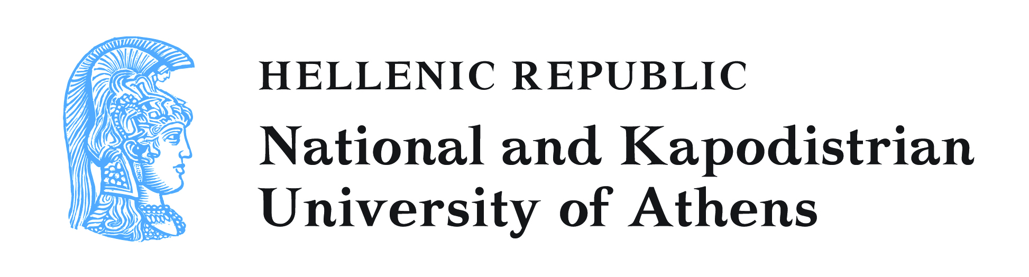


XVI UNIVERSEUM NETWORK MEETING
University Heritage and Cultural Engagement of European Universities
Athens University, Greece, 11‐13 June 2015

Registration Form

First Name
Last Name
Institution
Job Title
Mailing Address
Postal Code
City
Country
Phone
Fax
Email

Are you or your Institution member of UNIVERSEUM? YES NO

Have you submitted or plan to submit an abstract for a presentation? YES NO

Have you submitted or plan to submit an abstract for a poster? YES NO

Are you planning to attend the conference dinner on Thursday, 11thJune?
YES NO
(cost ca 15 euros).
Are you a vegetarian? YES NO
Are you planning to attend the post conference tour to Sounio-Lavrio
(archaeological site & Technological Park), Sunday, 14th June? YES NO
(cost ca 30 euros).
Do you have any problems of mobility? YES NO
(if yes, please specify__________________)
Thank you for completing the UNIVERSEUM Registration Form.
Please send it to universeum2015@uoa.gr

